**KDM : ICP 11**

Name : Aravind Yanamal

Student Id:

Here I am discussing about (CNN) conventional neural network. So I am building CNN using keras library.

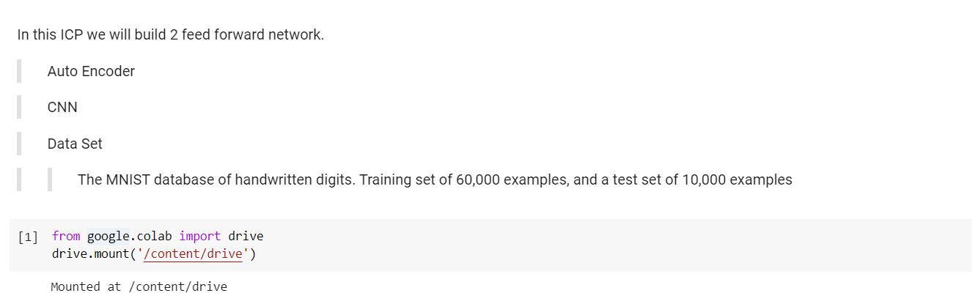

Here I am importing cifar10 dataset using keras.

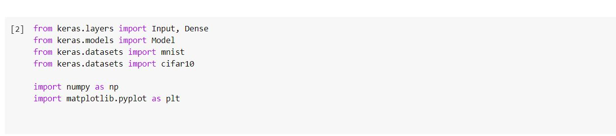

Here I downloaded the dataset.

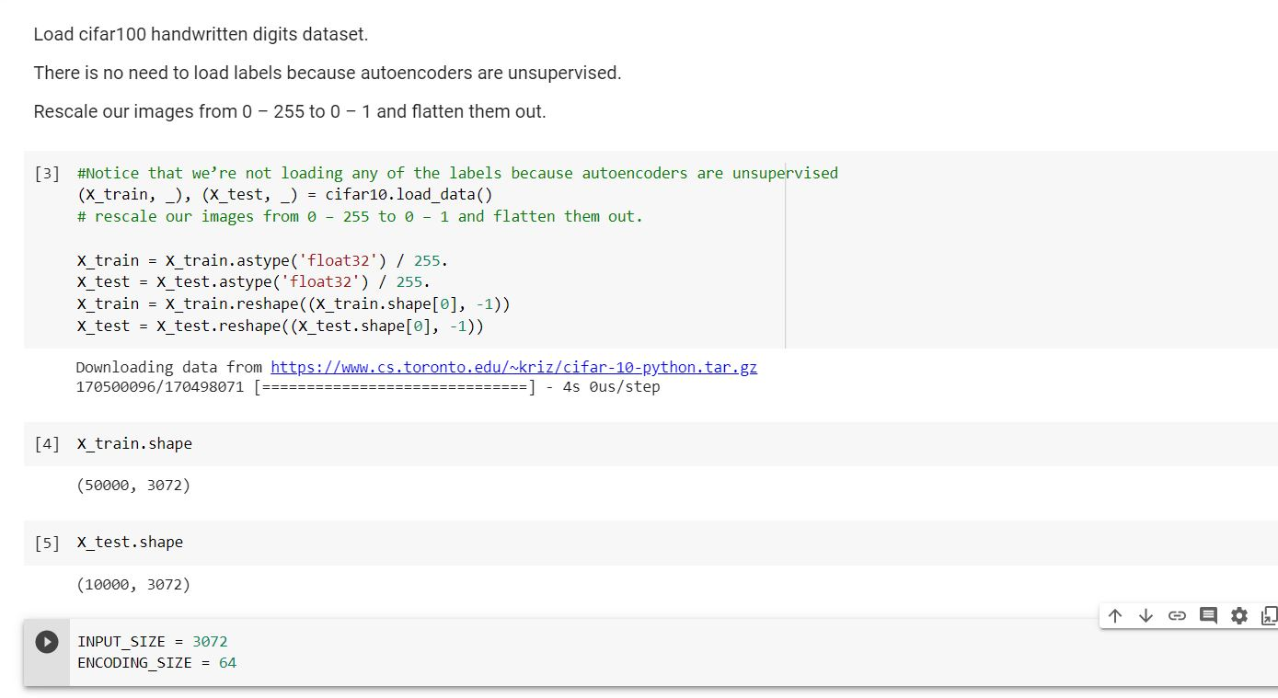

Here I added one layer. First I need to encode and then decode the layer.so according to the dataset I added the one encoded layer and one decoded layer.

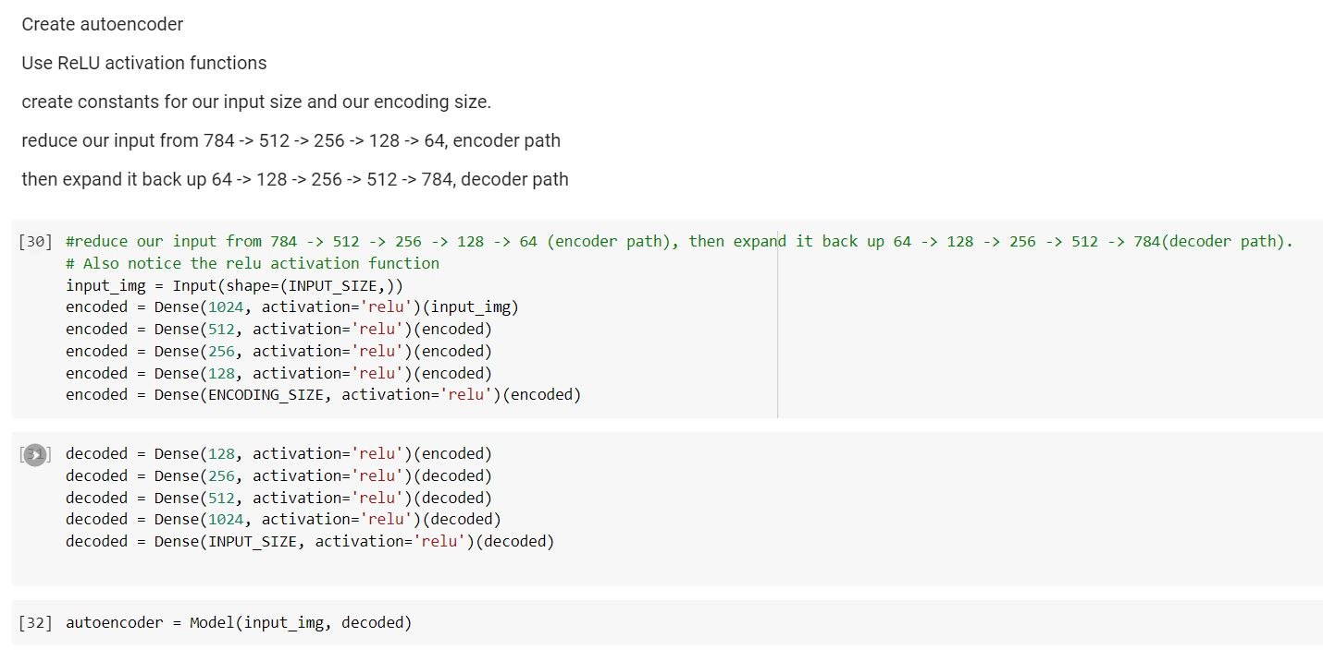

ADAM optimizer:

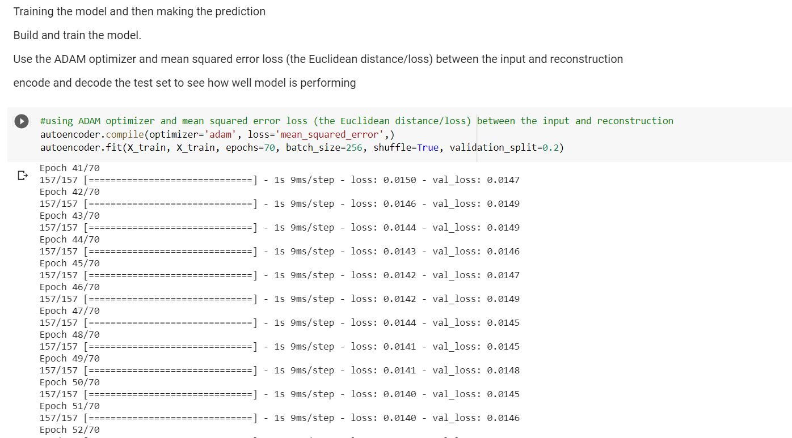

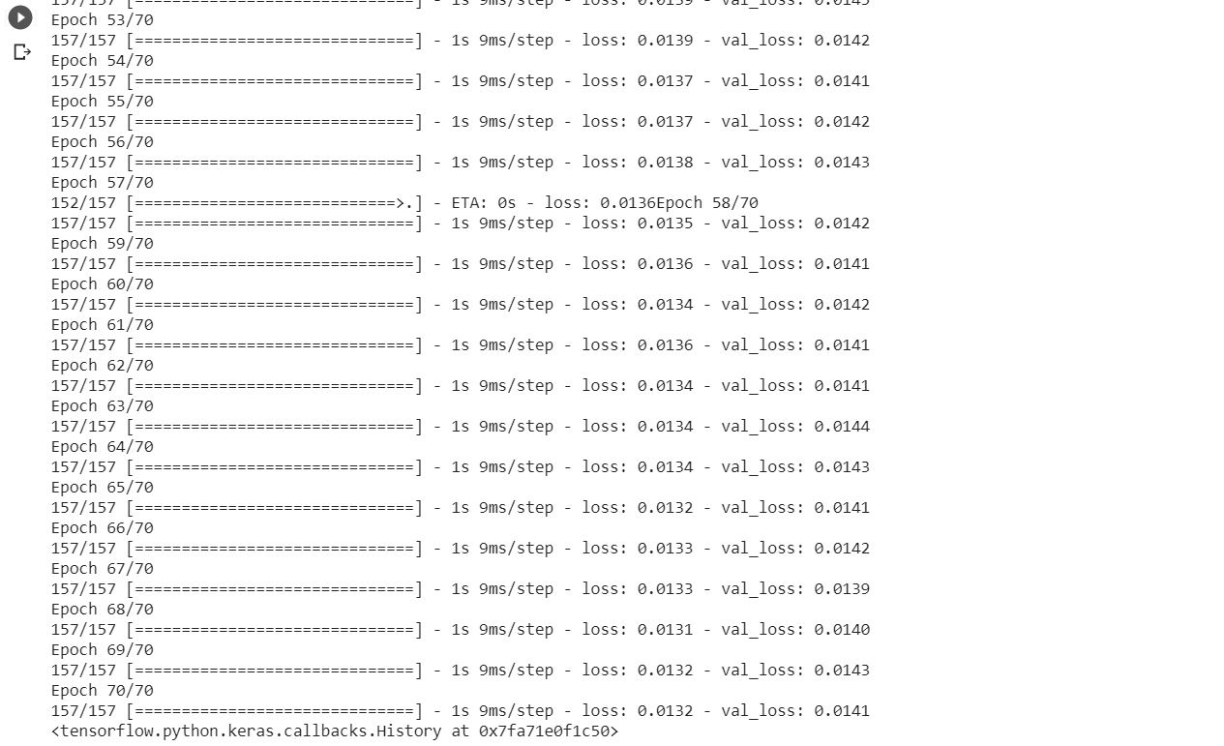

Here I took the input size as 30 images.

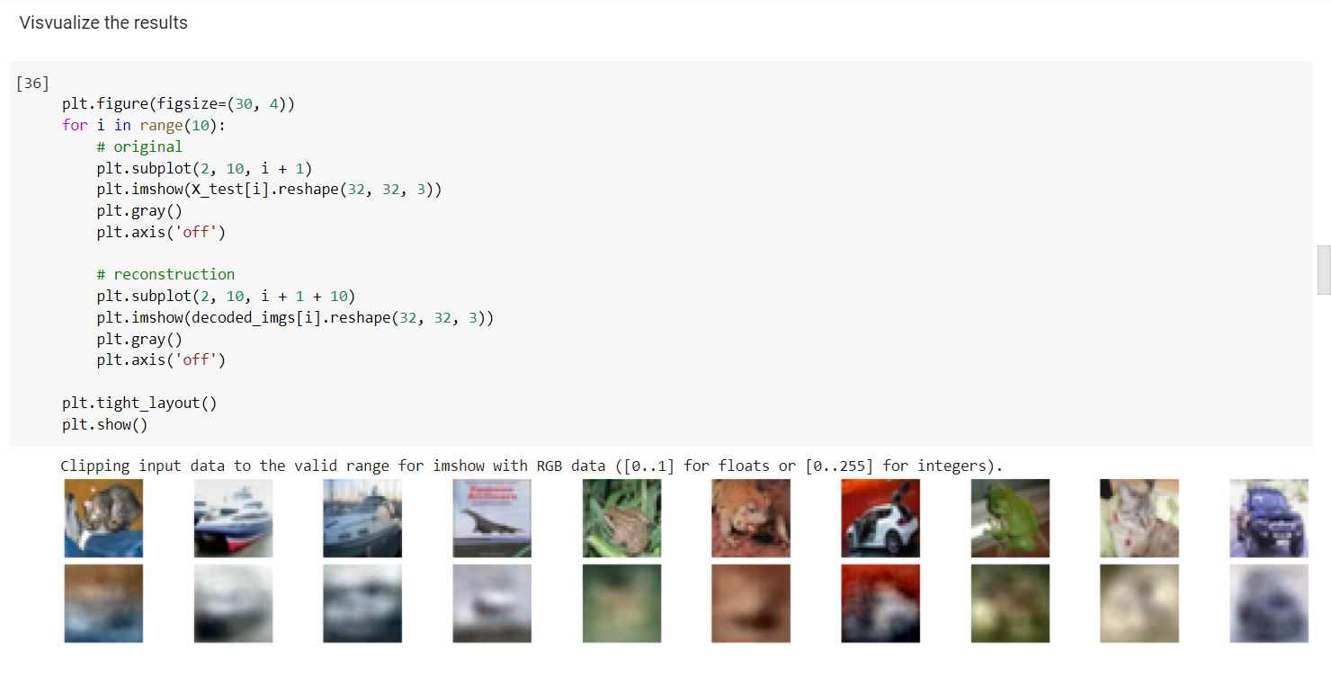

I imported cifar10 dataset from keras.

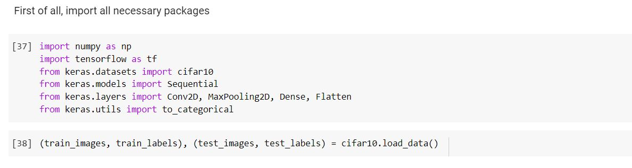

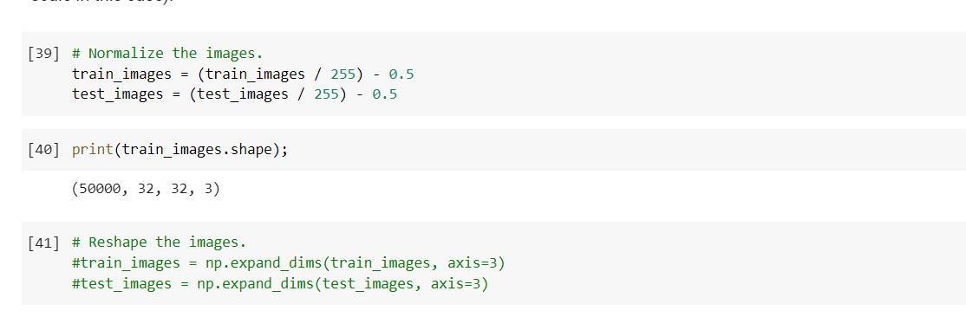

I changed the num_filters=12,filter_size=5 and pool_size=2.

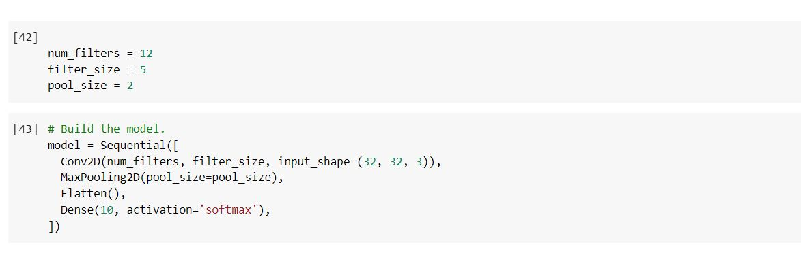

After building the model I compiled the model.

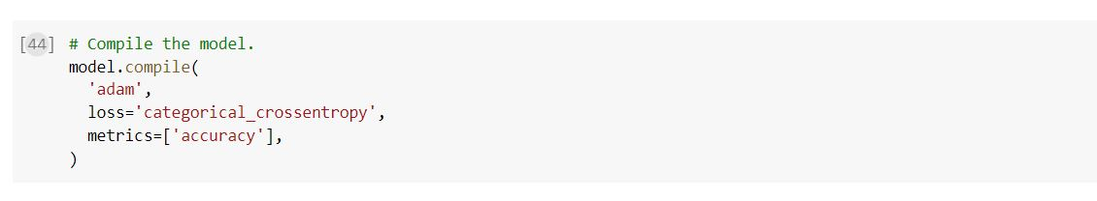

Train the model.

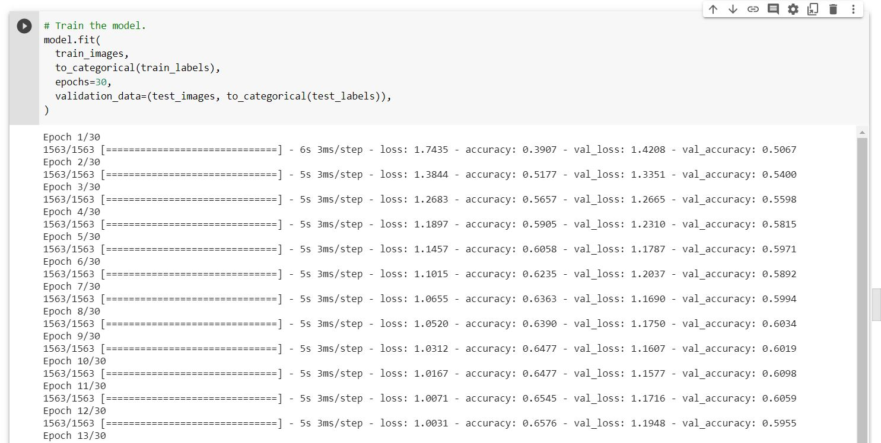

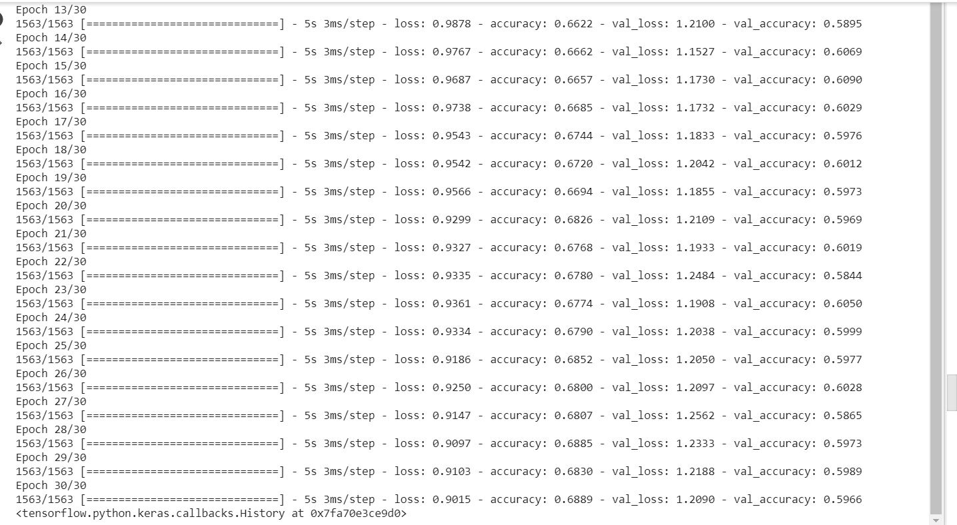

Predict on the first 20 test images and printed the prediction model.

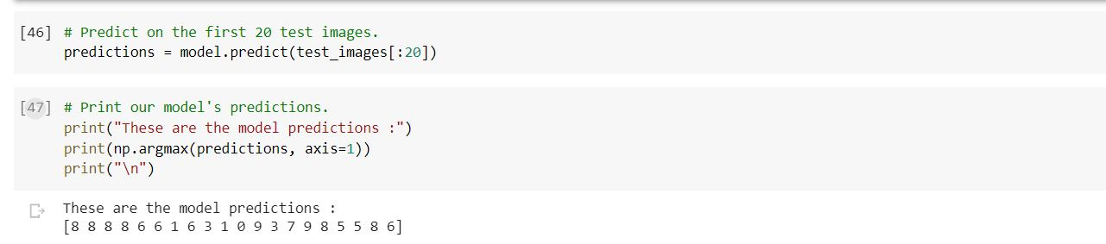

Prediction done against the ground truths.

